VA Salesforce Project XYZ

Technical Design Documentation



Department of Veterans Affairs

March 2017

Version 1.1

Revision History

|  |  |  |  |
| --- | --- | --- | --- |
| Version | Date | Author | Description |
| 1.0 | 01/28/17 | CoE Team | Initial Version |
| 1.1 | 03/01/17 | CoE Team | Revised |
| 1.2 | 5/31/18 | DTC Team | Added |

Table of Contents

Introduction 5

1.1 Objective of the Document 5

1.2 Glossary 5

Data and Visibility 6

2.1 The Data Model 6

2.1.1 The XXX object 6

2.1.2 The YYY object 6

2.2 The Security Model 7

The Users and the User Permissions 8

3.1 The User Roles 8

3.2 User Permissions 8

3.2.1 Data Access Permissions 8

3.3 The User Configuration 9

3.3.1 The Permission Sets 9

3.3.2 The Profiles 9

3.3.3 The User Detail Screen 9

3.4 Access to the Application and User login 10

3.4.1 SSO 10

3.4.2 Community 10

Process 10

4.1 The Macro-Process 10

4.1.1 The Schema of the Process for Module XXX 10

4.1.2 Description of Steps 10

4.1.3 The XXX Processing Permissions 11

4.2 Step by Step Process (needed if process is complex and needs further details) 12

4.2.1 The Process XXX and Sub-Processes 12

4.2.2 The Process XXX 12

4.3 Workflows 13

4.4 Process Flows 13

4.5 Apex Triggers 13

4.6 Visual Force Pages 13

4.7 Report Types 13

4.8 Apex Classes 13

4.9 Visual Flows 13

4.10 Custom Metadata 13

4.11 Page Layouts 13

4.12 Record Types 13

4.13 EinStein Analytics Dataflows/Dashboards 14

4.14 Batch Jobs 14

4.15 Other Custom Components 14

4.16 The Custom Settings 14

4.16.1 Custom Setting 1 14

4.16.2 Custom Setting 1 Picklist Dependency 14

4.17 The Custom Labels 15

Other Components 16

4.18 Any other custom components not covered above. 16

Managed Packages 16

4.19 Describe any dependent managed packages that will be used by this app (Appexchange). 16

Integrations 16

4.20 The technical interfaces 16

4.21 The schema of the data flows for the interfaces 16

4.22 The web service calls 17

4.23 The interfaces managed by the ETL 17

4.24 Other documentation about the interfaces 17

4.24.1 Documentation for the web service calls from Salesforce 18

4.24.2 Documentation of the ETL interfaces 18

4.24.3 Documentation for the web services 18

4.24.4 Documentation for XXX interfaces 18

# Introduction

## Objective of the Document

This document describes the technical features and implementation of the Salesforce module XXX.

Briefly describe project XXX.

## Glossary

Table 1

| Word | Definition |
| --- | --- |
| XXX | Definition |
|  |  |
|  |  |
|  |  |
|  |  |
|  |  |
|  |  |
|  |  |

# Data and Visibility

## The Data Model

The objects used in the module with their links are displayed in the data model below.

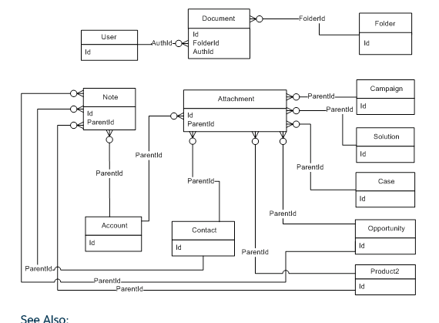

Figure 1: Data Model

The data dictionary is published in the workbook document *LV-SPO-Workbook-v1.0.xlsx*.

### The XXX object

Brief description of the custom object XXX.

### The YYY object

Brief description of custom object YYY.

## The Security Model

The Salesforce object’s visibility is controlled at the top level by the security model of visibility defined for the object.

The object visibility may be:

* Public read only
* Public read write
* Private (only visible by its owner)
* Controlled by parent

A private object can be shared from a public group; a role; a role and all its subordinates to a public group; a role; and / or a role and all its subordinates. The table below shows the security model defined for each object:

Table 2: Security Model

|  |  |  |  |
| --- | --- | --- | --- |
| Object | Public read only | Private | Controlled by parent (Opportunity) |
|  |  | X |  |
|  |  | X |  |
|  |  |  | X |
|  |  |  | X |
|  | X |  |  |
|  | X |  |  |
|  | X |  |  |
|  | X |  |  |

# The Users and the User Permissions

## The User Roles

Three user roles are involved in the special-order process:

Table 3:User Roles

|  |  |  |
| --- | --- | --- |
| Role | Who | Action |
| xxx |  |  |
| Production | One person per product category:   * Leather goods * Accessories * Watches | The production user makes or refuses the quotation, manages the creation and supervises the order during the production phase. |
| Other | Can be the zone approver, the marketing approver, the super CA the client service center or anyone else. |  |

## User Permissions

### Data Access Permissions

In Salesforce, each user is linked to only one profile. The profile defines the kinds of operations a user can apply on each object (create, read, write, delete).

Table 4:Permission Sets

|  |  |  |  |  |  |  |  |  |  |  |  |  |  |  |  |  |
| --- | --- | --- | --- | --- | --- | --- | --- | --- | --- | --- | --- | --- | --- | --- | --- | --- |
| **Permission** | Read | Create | Modify | Delete | Read | Create | Modify | Delete | Read | Create | Modify | Delete | Read | Create | Modify | Delete |
| **Object** | **Permission set/profile XXX** | | | | **YYY** | | | | **ZZZ** | | | | **All users** | | | |
| **xxx** | ✓ | ✓ | ✓ |  | ✓ | ✓ | ✓ |  | ✓ |  | ✓ |  | ✓ |  |  |  |
| **xxx** | ✓ | ✓ | ✓ |  | ✓ | ✓ | ✓ |  | ✓ |  | ✓ |  | ✓ |  | ✓ |  |
| **xxx** | ✓ |  |  |  | ✓ |  |  |  | ✓ |  |  |  | ✓ | ✓ | ✓ |  |
| **xxx** | ✓ | ✓ |  |  | ✓ | ✓ |  |  | ✓ |  | ✓ |  | ✓ | ✓ |  |  |
| **xxxx** | ✓ |  |  |  | ✓ |  |  |  | ✓ |  |  |  | ✓ |  |  |  |
| **xxxx** | ✓ |  |  |  | ✓ |  |  |  | ✓ |  |  |  | ✓ |  |  |  |
| **xxx** | ✓ |  |  |  | ✓ |  |  |  | ✓ |  |  |  | ✓ |  |  |  |
| **xxx** | ✓ |  |  |  | ✓ |  |  |  | ✓ |  |  |  | ✓ |  |  |  |

## The User Configuration

### The Permission Sets

Permissions sets give the users permissions on all the components elements of the module (objects, pages, module) and defines the role of the user.

Seven permission sets have been created for the XXX module:

* XXX
* YYY

### The Profiles

What profiles will your users for module XXX get?

### The User Detail Screen

All the information which defines the permissions and the role of the user are updated in the user form:

* The Profile
* Role
* The Permission Set

Here are different permission sets available according the user role & profile for this module:

Table 5:User Roles and Permission

|  |  |  |
| --- | --- | --- |
| User role | Salesforce Profile | Salesforce Permission set |
|  |  |  |
|  |  |  |
|  |  |  |

**Please note:**

* Any special notes.

## Access to the Application and User login

### SSO

What SSO configuration is used for the users for project XXX

### Community

What community (if any) are the users to be included.

# Process

## The Macro-Process

### The Schema of the Process for Module XXX

EXAMPLE:

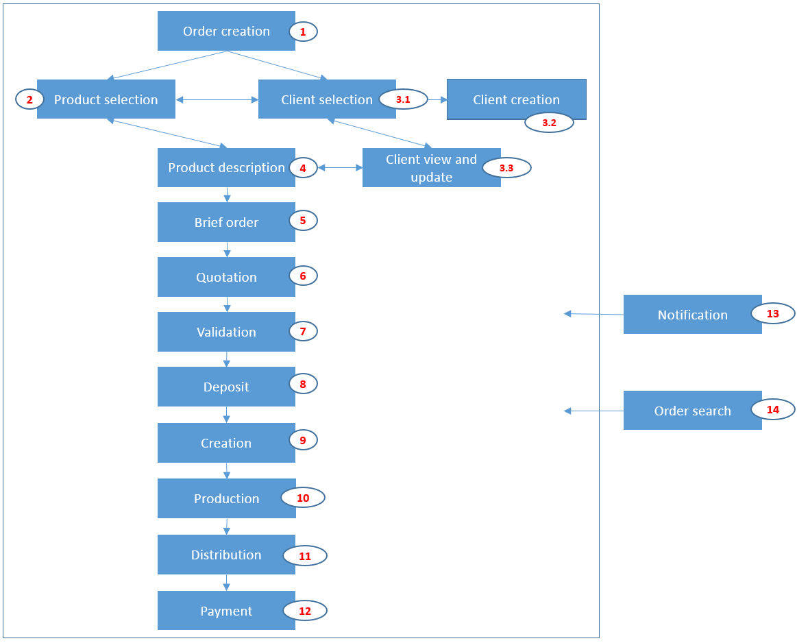

Figure 2:Macro-Process

### Description of Steps

The main steps are described in the table below.

The steps may be skipped depending on the type of special order.

Table 6:Macro-Process

| # | Main process features | Comment | Ref. |
| --- | --- | --- | --- |
| 1 | Order creation | A new special order is created with the mandatory information: the store, the CA code |  |
| 2 | Base product selection | The base product is selected in Salesforce in the Product Referential object. |  |
| 3.1  3.2  3.3 |  |  |  |
| 4 |  |  |  |
| 5 |  |  |  |

### The XXX Processing Permissions

The permissions are described in the table below. All users have the same permissions as the store user if they created a product order and they are consequently the owner of the special order.

Table 7:User Permissions

| Action / Users | User type 1 | User type 2 | All others |
| --- | --- | --- | --- |
| Search | Allowed | Allowed | Allowed |
| Create Case | All (1) | All | All (1) |
| Create new object X | Yes | No | No |
|  |  |  |  |
|  |  |  |  |

1. Footnotes for anything above
2. Footnote 2

## Step by Step Process (needed if process is complex and needs further details)

### The Process XXX and Sub-Processes

The client selection and creation process is described in the schema below.

EXAMPLE:

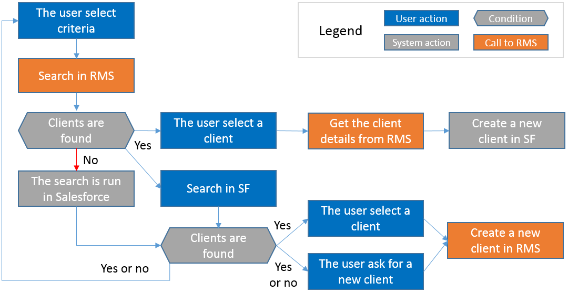

Figure 3:Selection Process

### The Process XXX

Table 8:Process XXX

|  |  |  |
| --- | --- | --- |
| User | XXXX | Description |
| Status | Case Created |  |
| Next status |  |  |
| Skipped | If there is a case already in the system |  |
| Description | The user attempts to enter the case,  Error received if the case already exists,  User enters following details for the case:  X, y, z. | Any special notes:  Following fields are required, etc. |
| Salesforce object | Ex. Case |  |
| Updated fields |  |  |
| Layout, Visual force page, Workflow, Process Builder, Visual Flow |  |  |

## Workflows

This section describes all the workflows.

## Process Flows

This section describes all the process builder flows.

## Apex Triggers

This section describes all the Apex triggers (with approval codes for exception request – TBD in VA).

## Visual Force Pages

This section describes all the VF pages (with approval codes for exception request – TBD in VA).

## Report Types

This section describes all the Report Types.

## Apex Classes

This section describes all the Apex Classes (with approval codes for exception request – TBD in VA).

## Visual Flows

This section describes all the Visual Flows.

## Custom Metadata

This section describes all the Custom Metadata (with approval codes for exception request – TBD in VA).

## Page Layouts

This section describes all the Page Layouts.

## Record Types

This section describes all the Record Types.

## EinStein Analytics Dataflows/Dashboards

This section describes all the EinStein Analytics Dataflows/Dashboards.

## Batch Jobs

This section describes all the Batch Jobs.

## Other Custom Components

This section describes any other customizations.

## The Custom Settings

XXX custom settings are used:

* Custom Setting 1
* Custom Setting 2

### Custom Setting 1

(screen shot ok)

Table 9

|  |  |  |
| --- | --- | --- |
| Name | Value | Comment |
|  |  |  |
|  |  |  |
|  |  |  |
|  |  |  |
|  |  |  |
|  |  |  |

### Custom Setting 1 Picklist Dependency

Table 10

|  |  |  |  |
| --- | --- | --- | --- |
| Name | Category | Referential Category | Record Type |
| Accessory | Accessories | Accessories | Special Order Accessory |
| Leather good | Leather goods | Leather Goods | Special Order Leather Good |
| Watch | Watches | Watches | Special Order Watch |

## The Custom Labels

The custom labels used are XXX.

# Other Components

## Any other custom components not covered above.

# Managed Packages

## Describe any dependent managed packages that will be used by this app (Appexchange).

# Integrations

## The technical interfaces

Three kinds of interfaces are used:

* Web services XXX
* The ETL Stage Database
* The XXX connector used by XXX

## The schema of the data flows for the interfaces

Table 11:Table of the interfaces

| **N°** | **Source** | **Destination** | **Type** | **Responsible** | **Comment** |
| --- | --- | --- | --- | --- | --- |
| 0 |  |  |  |  |  |
| 0 |  |  |  |  |  |
| 0 |  |  |  |  |  |
| 1 |  |  |  |  |  |
| 2 |  |  |  |  |  |
| 3 |  |  |  |  |  |
| 3 |  |  |  |  |  |
| 3 |  |  |  |  |  |
| 4.1 |  |  |  |  |  |
| 4.2 |  |  |  |  |  |
| 5 |  |  |  |  |  |
| 6 |  |  |  |  |  |
| 6 |  |  |  |  |  |
| 7 |  |  |  |  |  |
| 8 |  |  |  |  |  |

## The web service calls

## The interfaces managed by the ETL

Table 12

|  |  |  |
| --- | --- | --- |
| Source | Salesforce |  |
| Target | SAP |  |
| Periodicity | Each day |  |
| Master system | Salesforce |  |
| Salesforce object | XXX__c |  |
| Fields | XXX__c (key)  YYY__c  Object XXX. Abc__c | Special Notes |

## Other documentation about the interfaces

The detailed documentation is defined in different documentations depending on the kind of interface and the responsible of the realization.

### Documentation for the web service calls from Salesforce

### Documentation of the ETL interfaces

### Documentation for the web services

### Documentation for XXX interfaces